First Name: Last Name:

Institution: Title: All Authors (Full Name): Abstract (Maximum 350 words)

Note: Email:
Please submit abstracts for your oral or poster presentations online at Admin@pakendosociety.org

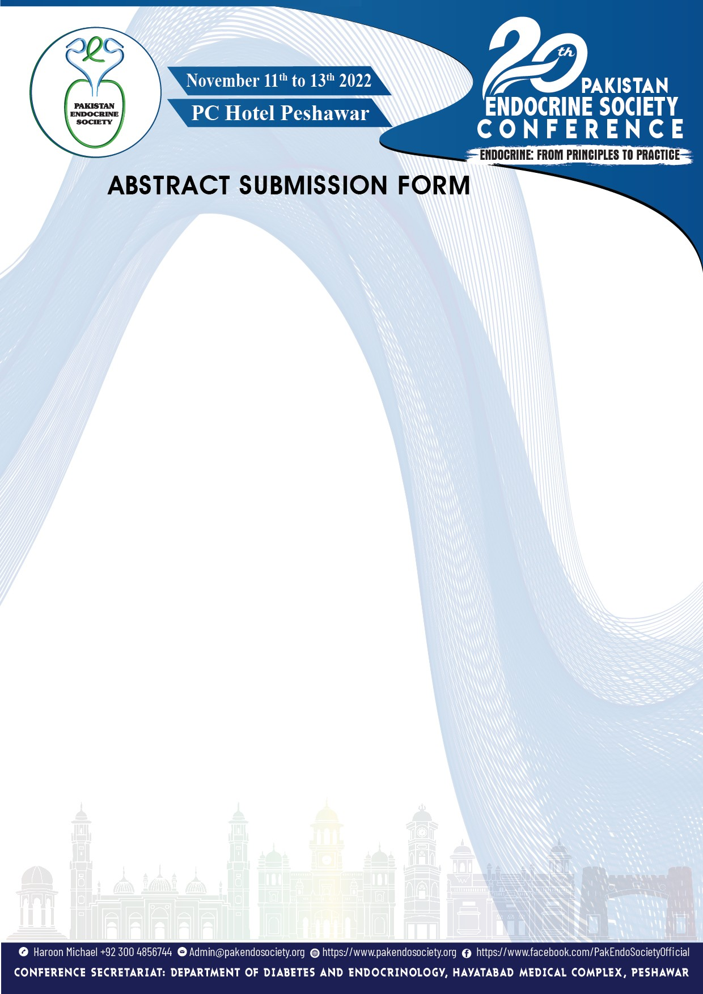Last Date of Abstract Submission 1st October 2022

